1. **Research**
2. Signup Page

COVIDSafe is one of the software that were purposely designed to prevent the spread of Covid-19 Virus by identifying and contacting people who may be exposed to the virus. The way this application works is that every user is required to provide their personal information, such as full name, age range, residential address, email address and phone number, in order to access this app. From that approach, it gave us some ideas about the information that we need to collect from our new users. However, in our project implementation, we are planning to make the information of residential addresses only available to the Health Department. Therefore, the Health Department could immediately access the users’ data to handle emergency situations. For example, sending an ambulance to the user’s residence who has covid symptoms. Another great feature from the COVIDSafe app is that they are using the Bluetooth technology to collect information about people that the user has been in close contact with by searching through other Bluetooth devices. Therefore, if someone is tested positive for Covid-19, the app will detect and notify every person that has been contacted to this person in the last 21 days. However, the downside of this feature is that if the user did not turn on their Bluetooth, then the ‘digital handshake’ will not work. In other words, the app will only be collecting data if the device and device’s Bluetooth are on.

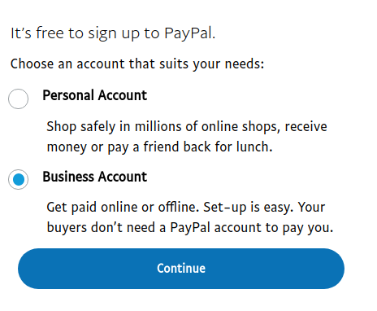

Other than that, we also got inspiration from Paypal to create a page to collect data of the roles of the users when they want to sign up for an account. Therefore, this will make us easier to identify the type of information that we need to collect from our new users. For example, if the user is signed up for a business venue, then they will need to provide the information of their business and do not need to provide the personal information, such as age.

1. Collecting Information

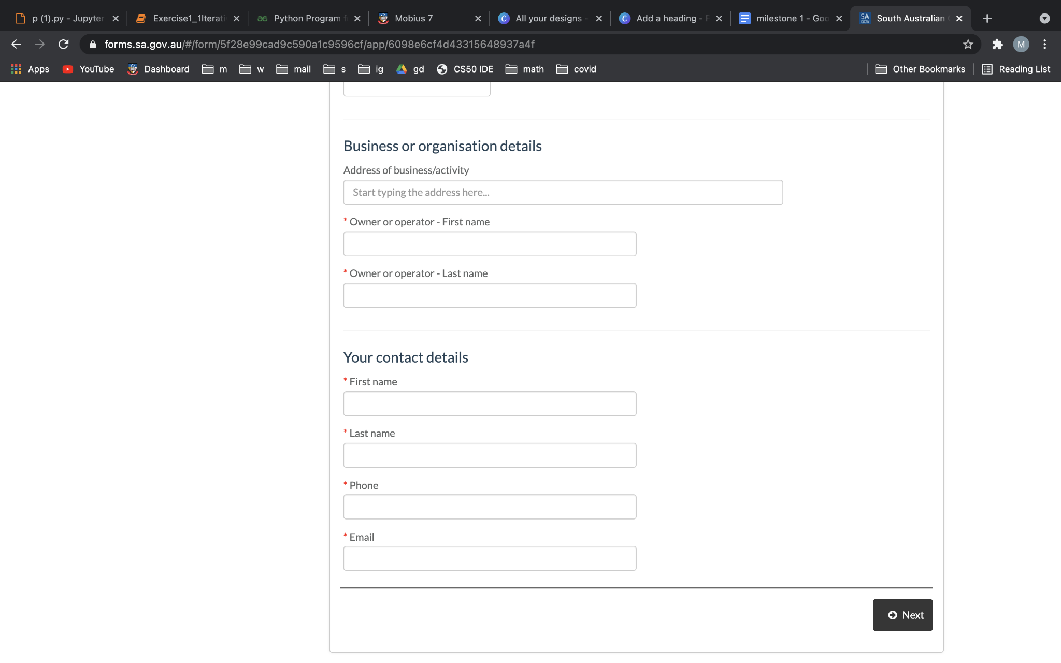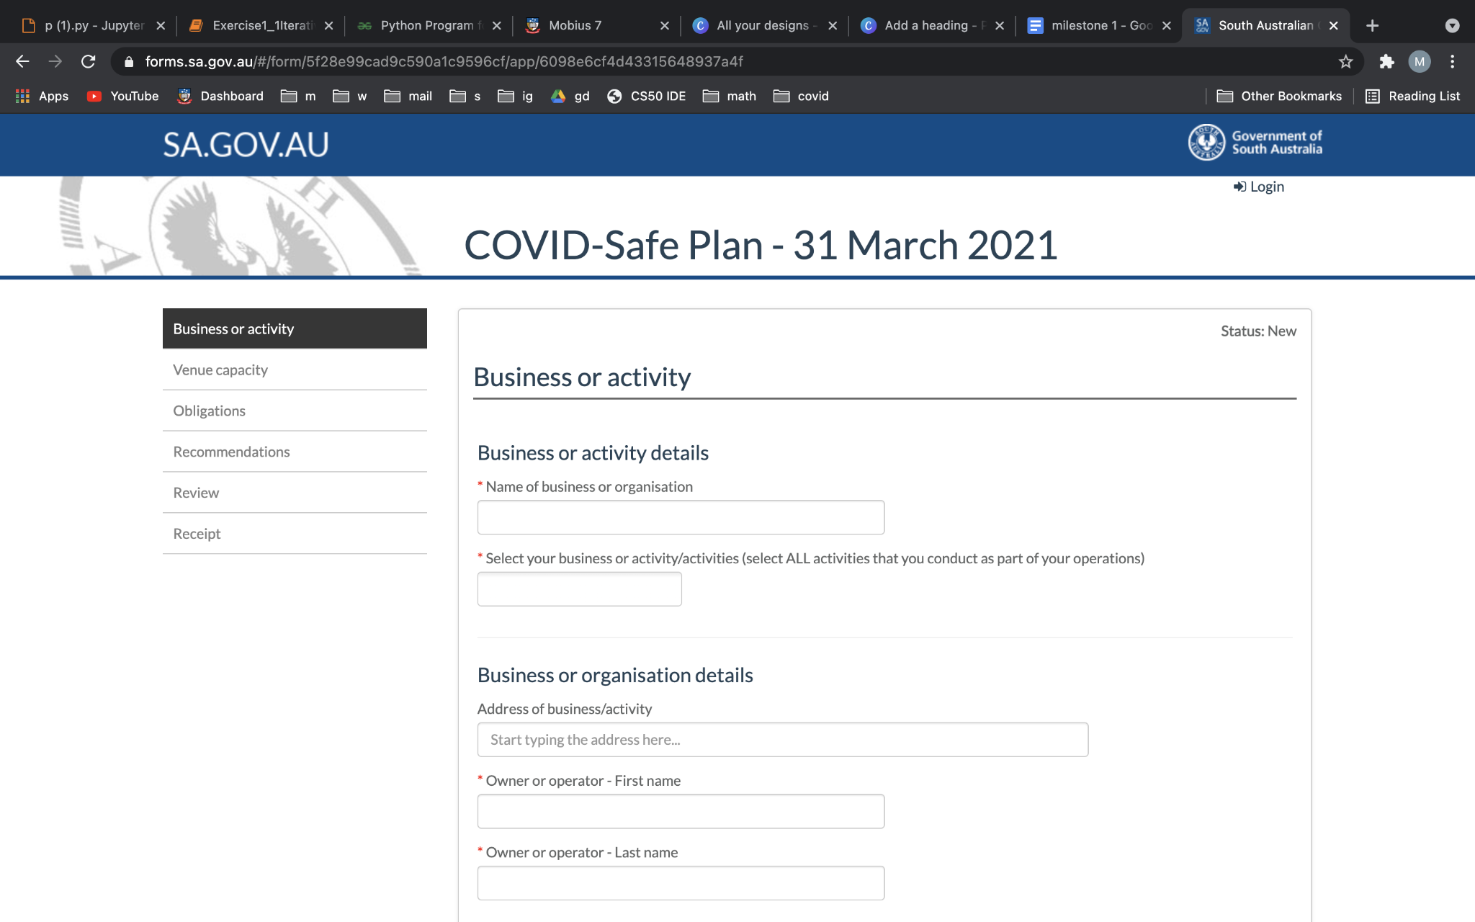

MySA GOV application also has a similar approach to our web application project. As we all know, the MySA GOV is an application that is widely used in South Australia in order to prevent the spread of Covid-19. Other than that, this app also enable the venue owners to register their venue in the app. In order to register their venue, the venue managers need to provide their venue information and they will be provided with a unique QR Code for their venue. Therefore, every visitor will need to check in by scanning the unique QR Code of the venue. By scanning the QR Code, the user’s browser will be redirected to a page to collect the user’s personal information. The personal information that the user needs to provide is their first name, last name and phone number. Through this app, our group has a better understanding on what type of information we should collect from our new users.

1. 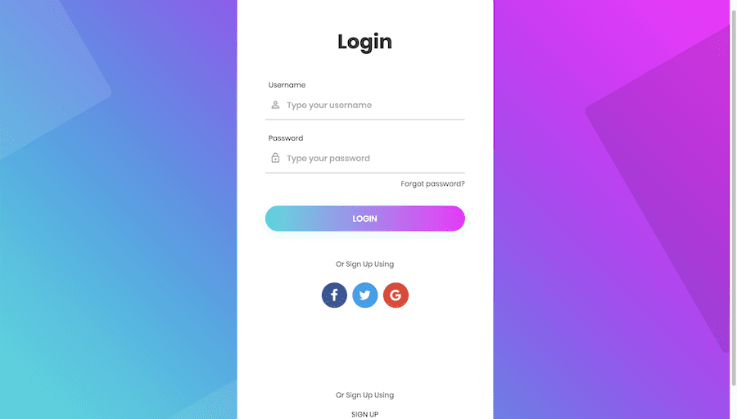Login Page

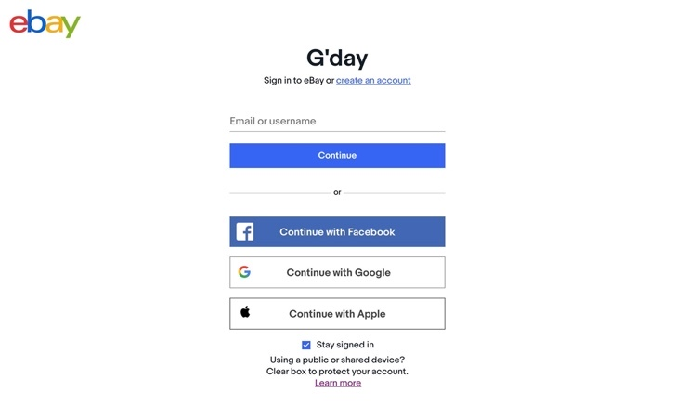

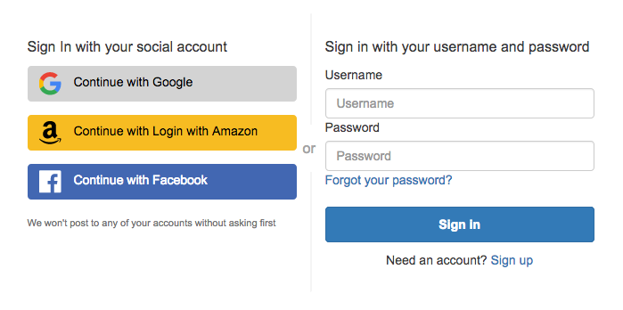

In terms of building our own login page, we gathered a few different designs through multiple sites that could inspire us on building our own login page. The websites that we would like to use as references are the Ebay and Amazon login page. Other than using username and password, Ebay and Amazon also enable the user to sign in into their website using their social media such as Facebook, Google Account or Apple account. Through these designs, we are inspired to enable our users to sign in using their social media, such as Facebook, Twitter or Gmail account. In our opinion, this method will make the log in process easier for the users and venue managers. Moreover, the Google and Facebook company are also providing information of API for the developers to implement it in their websites. In our logging in page, we will only show the logo of the social media options that allow the user to sign in with.

1. 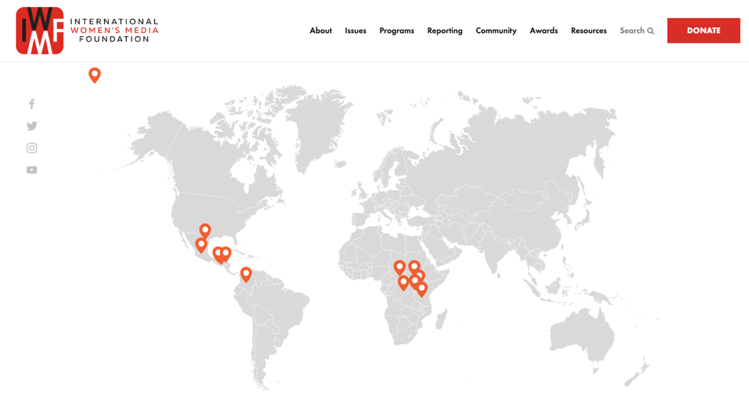Check-in using GPS

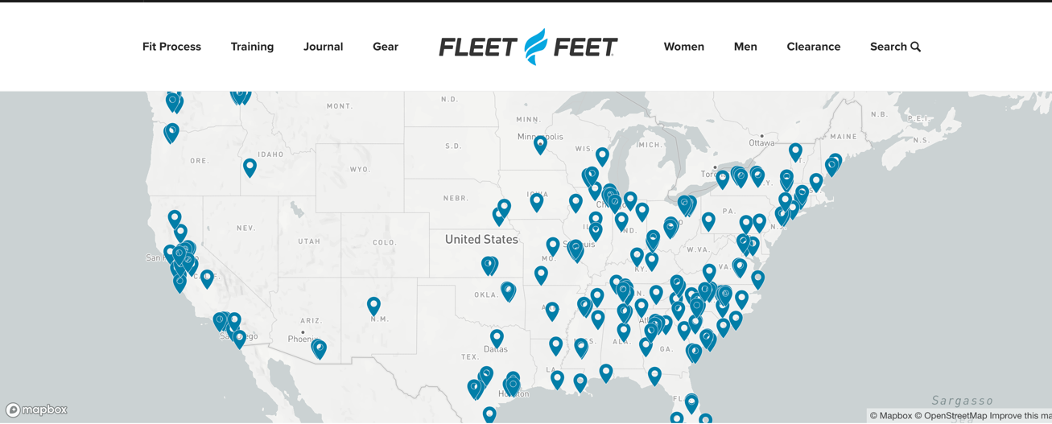

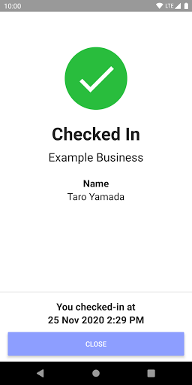

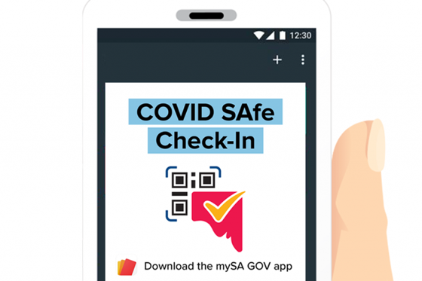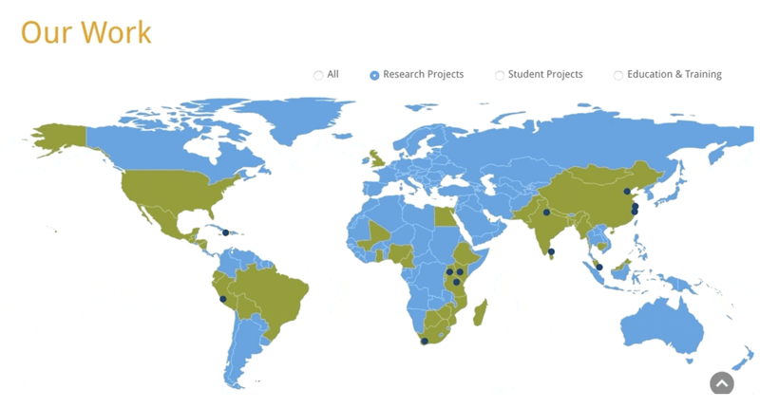

The approach that mySA GOV app collecting the check-in data of users is by using the QR code. Which every user need to scan the QR code of the venues that they visited, and the data will be saved on the app’s database. In this project, we will be using different approach from the mySA GOV app. Our group decided to implement the GPS technology for the user to check in instead of scanning a QR code. Through our research, we found that we could get the users’ current coordinate by using the function of “navigator.geolocation.getCurrentPosition”. For example, Google Map has the ability to detect the exact number of longitude and latitude of a venue address. Thus, if the GPS enables the users to check in to the venue using their current coordinate location, then we could collect the data of the users that visited the venue. All data of the users, locations and timestamps will be saved in a database using SQL. Therefore, the users will be able to access their check-in history and venue managers could get information of the users that visited their venue.

Other than that, the GPS would also enable us to show the users the current hotspots within an area, current position of user and the map consist of the check-in history. In order to show the current hotspots on the map, we got inspiration from the ‘Duke Global Health Institute’ which mark the part of the map with some color to show the location of their presence of their research around the world. We will also be using the same approach which we will mark the current hotspots with red circle which will represent the ‘red zone’. We will use a plug-in tool [<https://www.npmjs.com/package/mapbox-gl-draw-circle>] which will draw a circle on top of the map represent the hotspot area.

Additionally, in order to represent the map of check-in history of the users, we will use the same approach as the website of ‘International Women’s Media Foundation’ and ‘Fleet Fleet’ where they mark their area with some red and blue pins to show their location within an area. Therefore, in our website, we will be using some pins as the marker of the position of our users. This marker will represent the places that the users have checked in to. Thus, if the pins of recently visited places combined with the red zones circles, the users will easily identify whether they have been to the current hotspots just by looking at the map.

1. 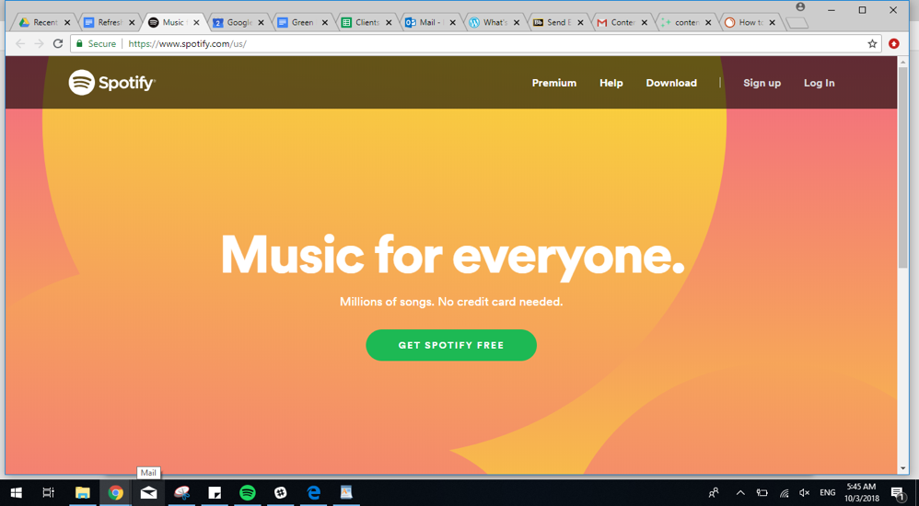Main Page

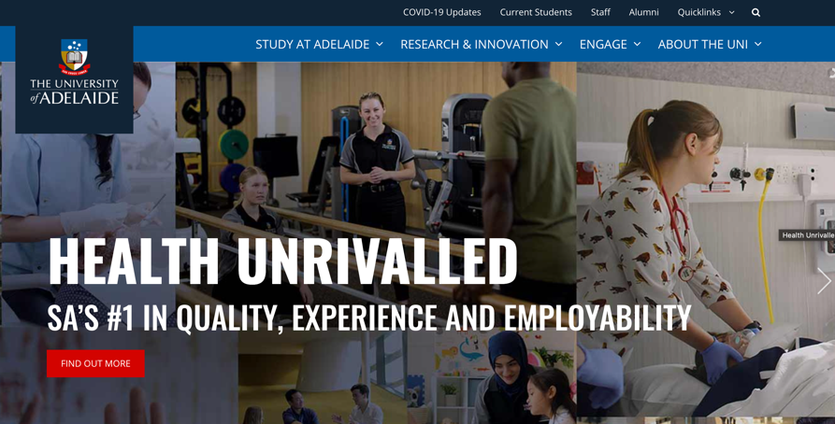

Main page is the most important part of every webpage as it will be the first thing that our user will see whenever they load into our webpage. Therefore, we want our webpage main page to be simple and straightforward. The Spotify webpage is a good example of a simple and straightforward webpage design. When the user got directed to the Spotify main page, the user directly could see that all of the buttons are placed on the right top corner. Thus, this will make the user easier to find and click the button that they want to use. The design of the website itself also simple and elegant which there are only a few important elements that are shown on the page. Therefore, it is more user-friendly that it will not make the user feel dizzy when they look at it. However, the downside of the Spotify webpage is that the background used on the main page is too bright, which might make some users feel uncomfortable while looking at it.

Another example of the design that go along with our webpage application design is the University of Adelaide’s main page. Our university adopted a similar design with the Spotify webpage, where every button is located on top right corner. Therefore, when the user want to find something on the website, they can directly look at the right top corner of the webpage to find the things that they desire. Other than that, the webpage of University of Adelaide also inspire us to set our webpage base color as dark blue. The combination of the blue and white colors created a perfect mixture to the users’ eye sights.

Additionally, both of the websites also inspire our group to place our logo on the left top corner of the main page. Therefore, the users could easily see and identify our website’s logo.

1. 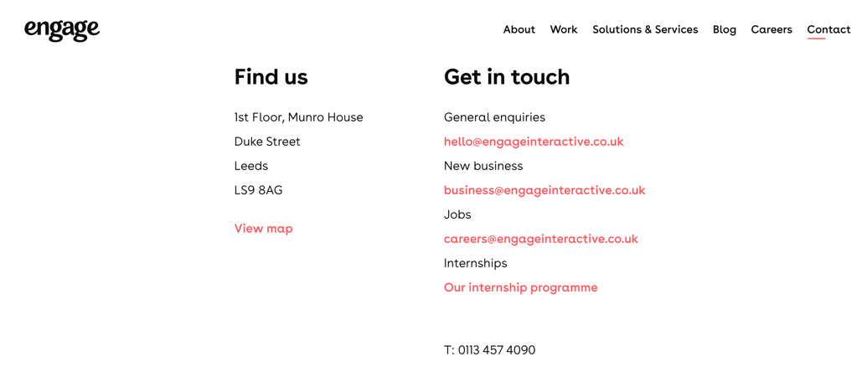Contact Us

We also considering on adding the ‘Contact Us’ feature on our webpage. Using the *engage* website as a reference, our Contact Us will contains the ‘Find us’ and ‘Get in touch’ information. The information provided will be the email, phone number and address.

1. **Basic Design**
2. 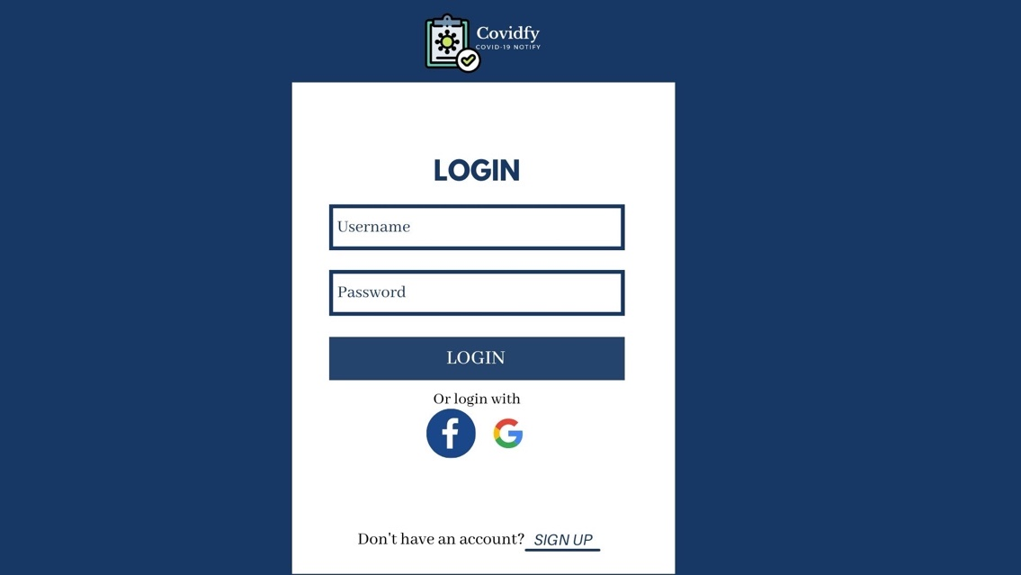Login Page

In the login page, the users will need to provide their username and password, or they could login using their linked account. The linked account that we implemented in our web application are by using Facebook and Google Account. Therefore, if the users already linked their Facebook or Google Account, they could immediately sign in to Covidfy without having to type their username and password. However, if the user does not have an account yet, the user is required to sign up their account by clicking the ‘Sign Up’ link, which will be redirected to the ‘Identify Role’ page. The website design of the login interface is in a phone layout. Thus, if the users are accessing the login page using their mobile phone, they layout will not need any adjustment and directly fit into their phone device. By clicking the login button, the users will immediately be redirected into the main page of our website.

1. 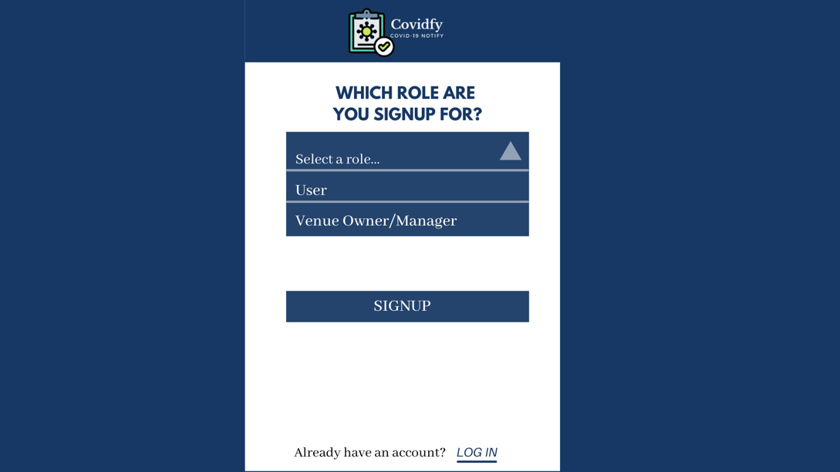Identify Role Page

When the user clicked the ‘Sign Up’ link, the user will be redirected to this page which require the new users to identify their role. This page will help us to determine what type of information we need to collect from the new users. The new users are required to pick one role before clicking the ‘Signup’ button and got redirected to the ‘Signup’ Page where we will collect the new user’s information. Moreover, we also added the ‘Login’ link on the bottom of the layout as if the user already have an account and miss-clicked to the ‘Signup’ page, they can go back to the ‘Login’ page.

1. Users
2. 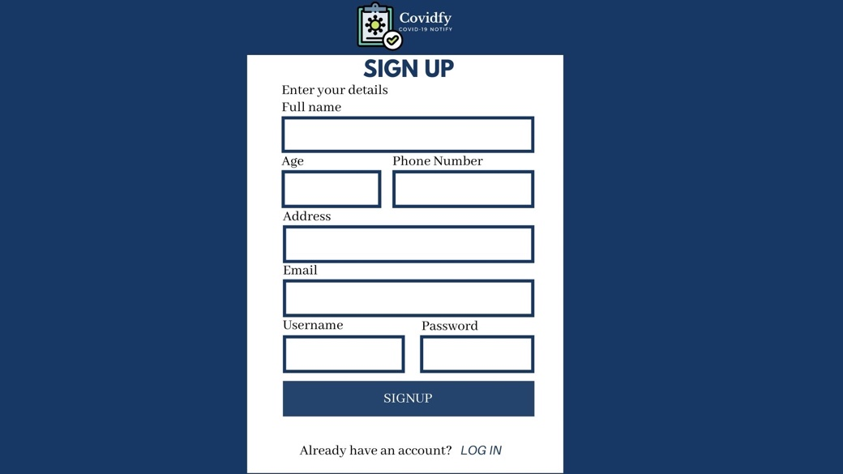Signup Page

If the new users picked the role of ‘User’, then they will be redirected to the ‘Signup’ page for user. In this page, the new users are required to provide their personal information, such as full name, age, phone number, address, email and they also required to create a username and password. The username and password will be used as the user’s identifier and being used to login to the Covidfy website. We also add the ‘Login’ link on the bottom of the page, just in case the user already have an existing account and it will be redirected to the ‘Login’ page.

1. 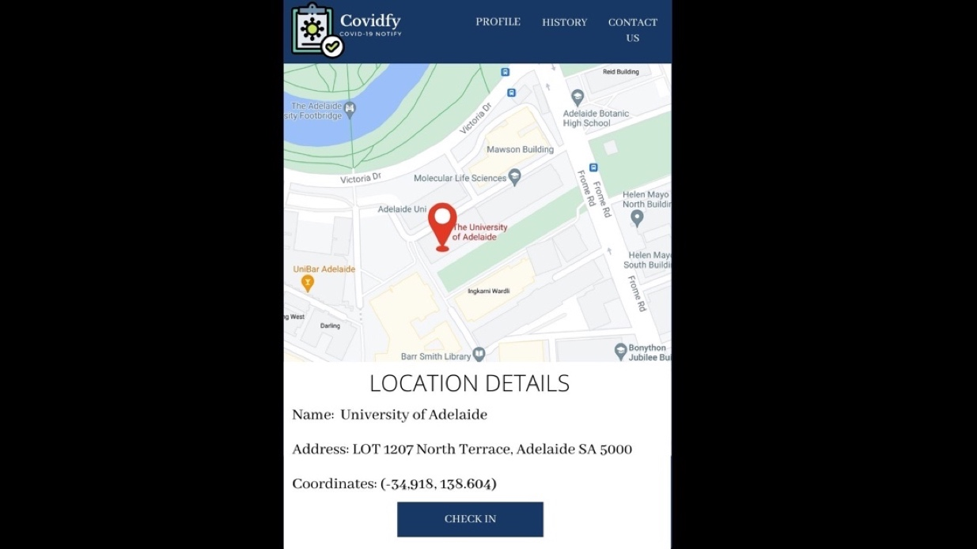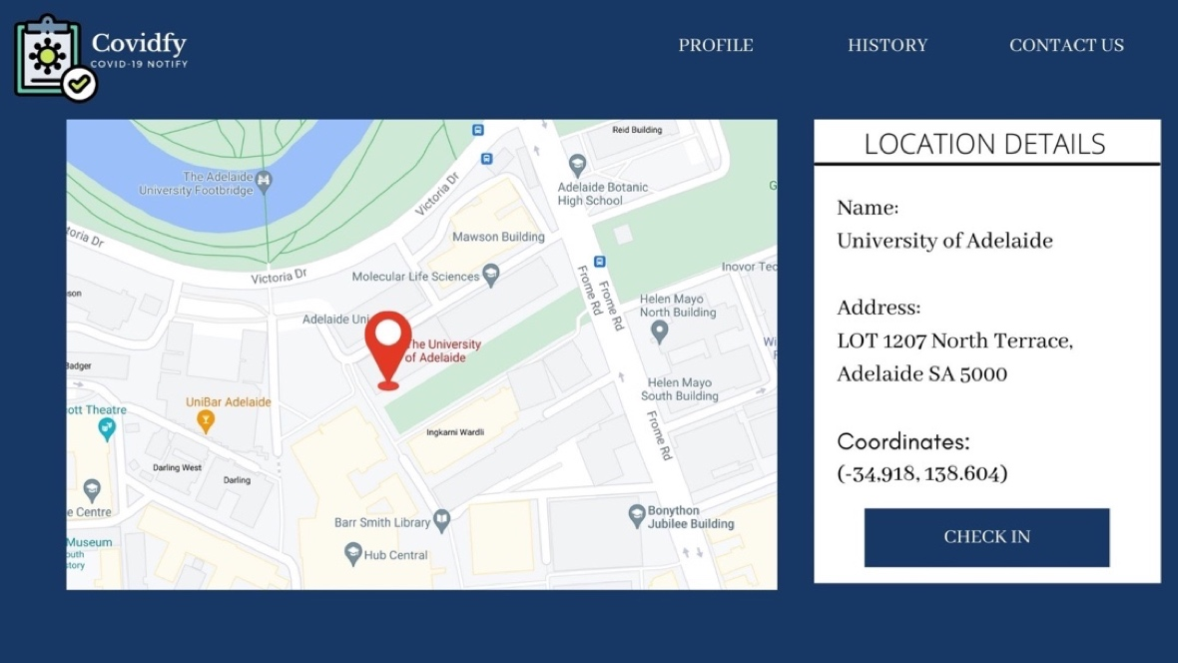Main Page

When the user logged in into their account, they will be redirected to the main page of the Covidfy webpage. In the main page of the user, it will show their current position, which will be mark by a marker and show the information of the location, such as the name of the location and the address. There will also be a ‘Check In’ button for the user to check in. For the user main pager, there will be 3 menu which is located on the right top of the webpage, which are ‘Profile’, ‘History’ and ‘Contact Us’. The implementation in the mobile’s version is the same but the location details information is moved to the bottom of the map of the current position. The menus in the mobile device will be smaller to fit into the mobile device.

1. 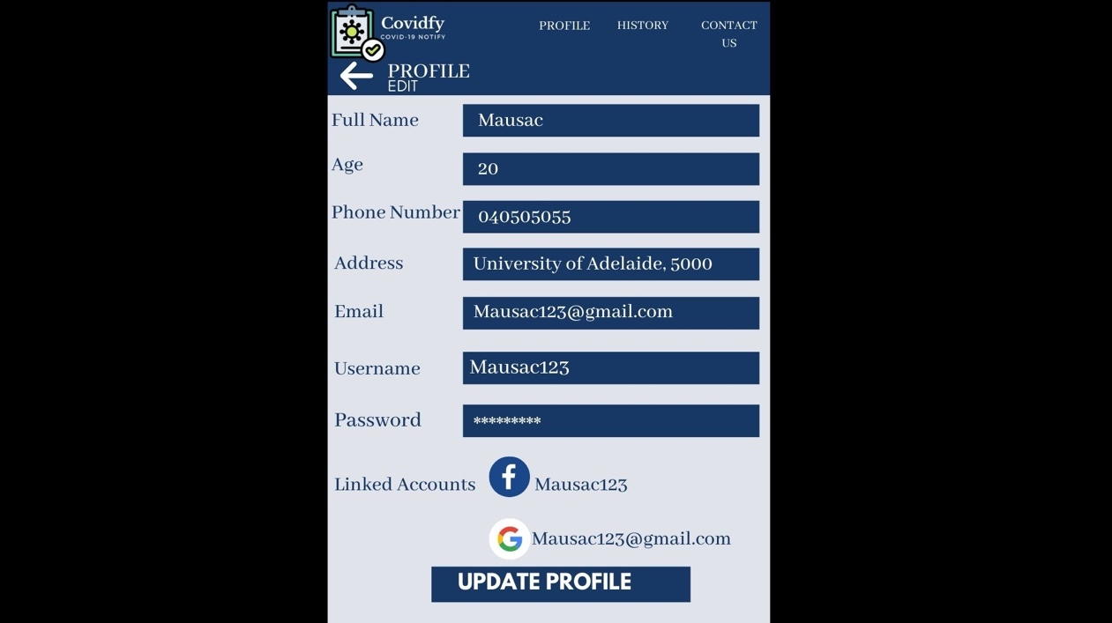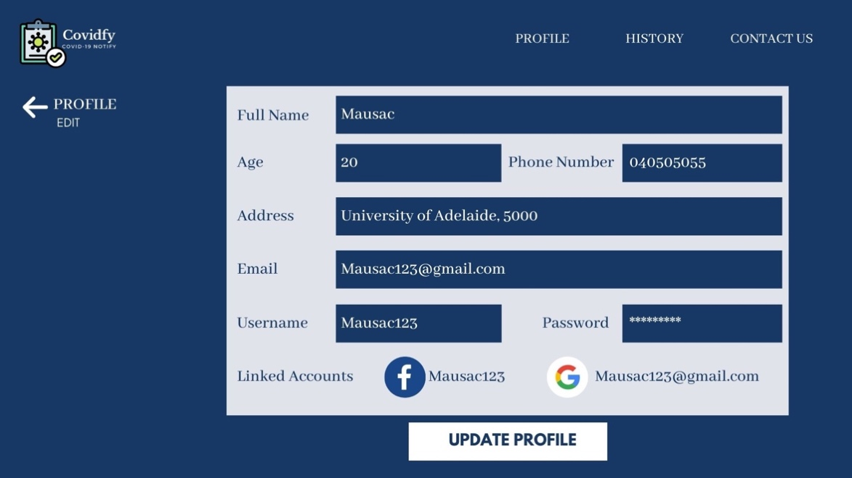Profile

The ‘Profile’ menu will allow the user to edit their personal information and link or unlink their Facebook and Google account. If the users make some changes to their profile, they need to click the ‘Update Profile’ button in order to save the changes. In the webpage, there is a back button on the left side of the page. For the mobile device layout, it will be the same layout, but it is fixed into a device’s size and the back button will be moved to the top of the edit profile box. The other menus will still be the same.

1. 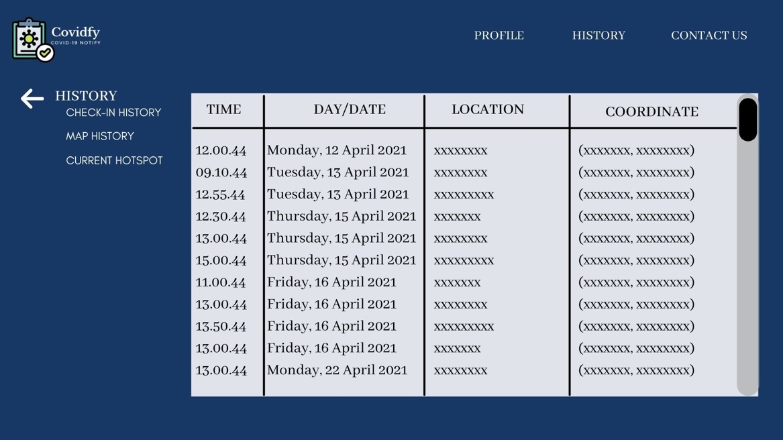History

(a) Check-in History

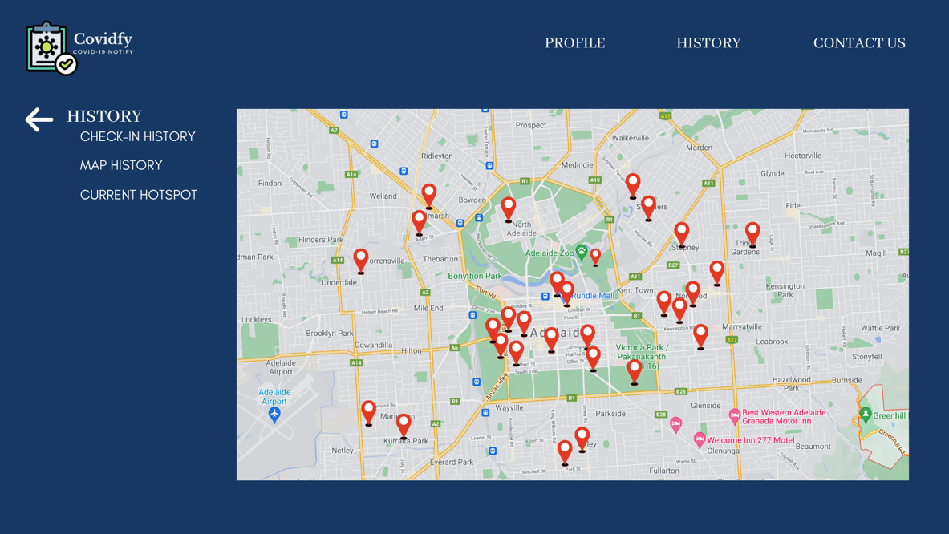

(b) Map History

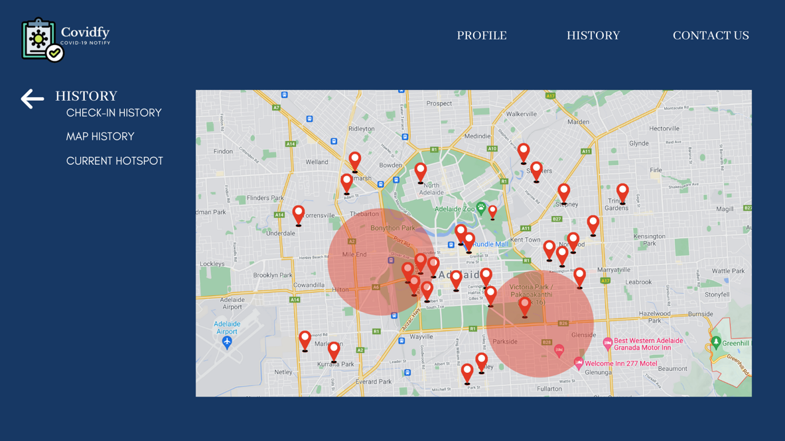

(c) Current Hotspot

In the user’s ‘History’ menu, there will be 3 sub menus, which are ‘Check-in History’, ‘Map History’ and ‘Current Hotspot’. On the ‘Check-in History’, it will show the check-in history information of the users. The information included are the timestamp (time and day/date), location and the coordinates. On the ‘Map History’, it will show the map with markers pointing on the location that the users have been to. While on the ‘Current Hotspot’ it will show the current red zones and the markers of user’s map history. Therefore, the user can easily identify whether they have gone to the red zone by just simply looking at the map. For example, if there are some markers in the red circle, it means that the user have been into the current hotspots and need to quarantine.

1. Venue Managers/Owners
2. 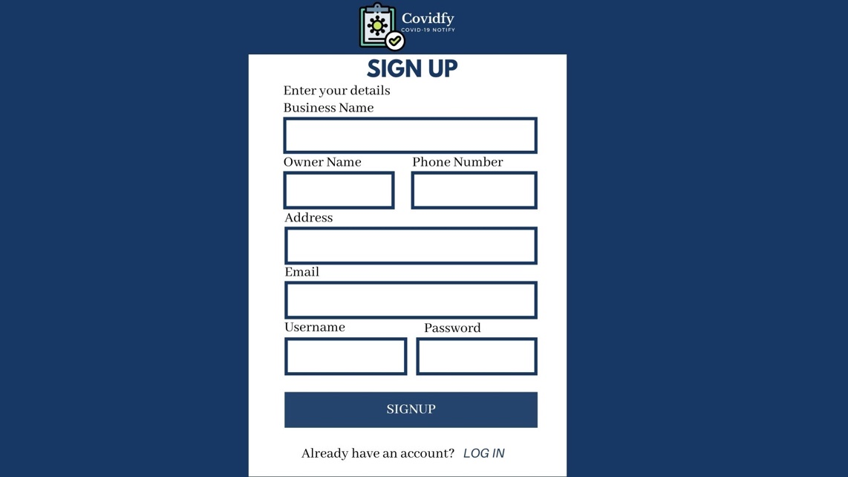Signup Page

If the new users picked the role of ‘Business Owner/Manager, then they will be redirected to the ‘Signup’ page for business owner/manager. In this page, the new users are required to provide information about their business, such as business name, owner name, phone number, address, email and they also required to create a username and password. The username and password will be used as the venue/business’ identifier and being used to login to the Covidfy website. We also add the ‘Login’ link on the bottom of the page, just in case the user already have an existing account and it will be redirected to the ‘Login’ page.

1. 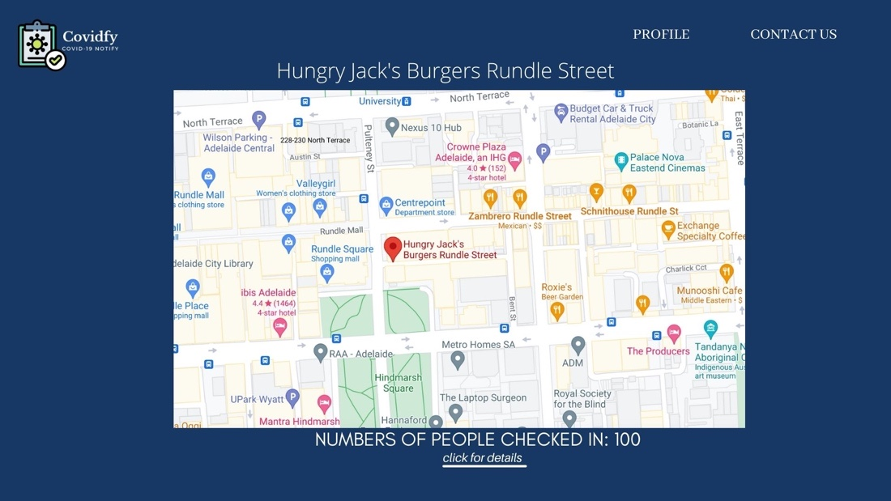Main Page

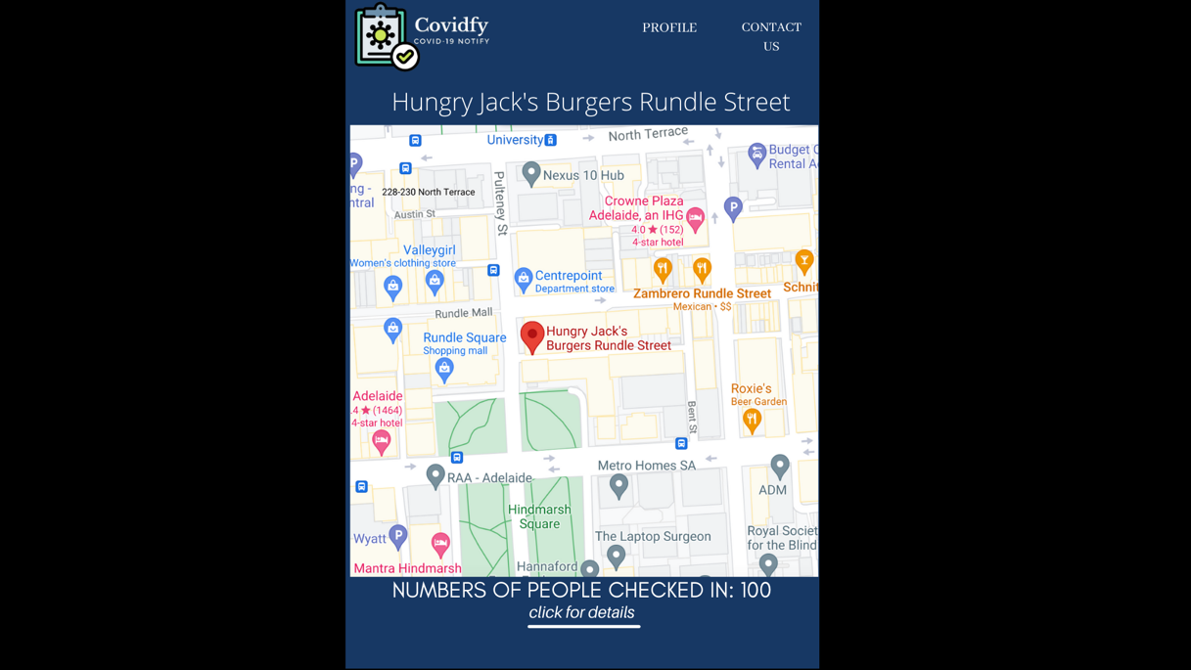

(a) Main Page for the Venue Manager/Owner layout

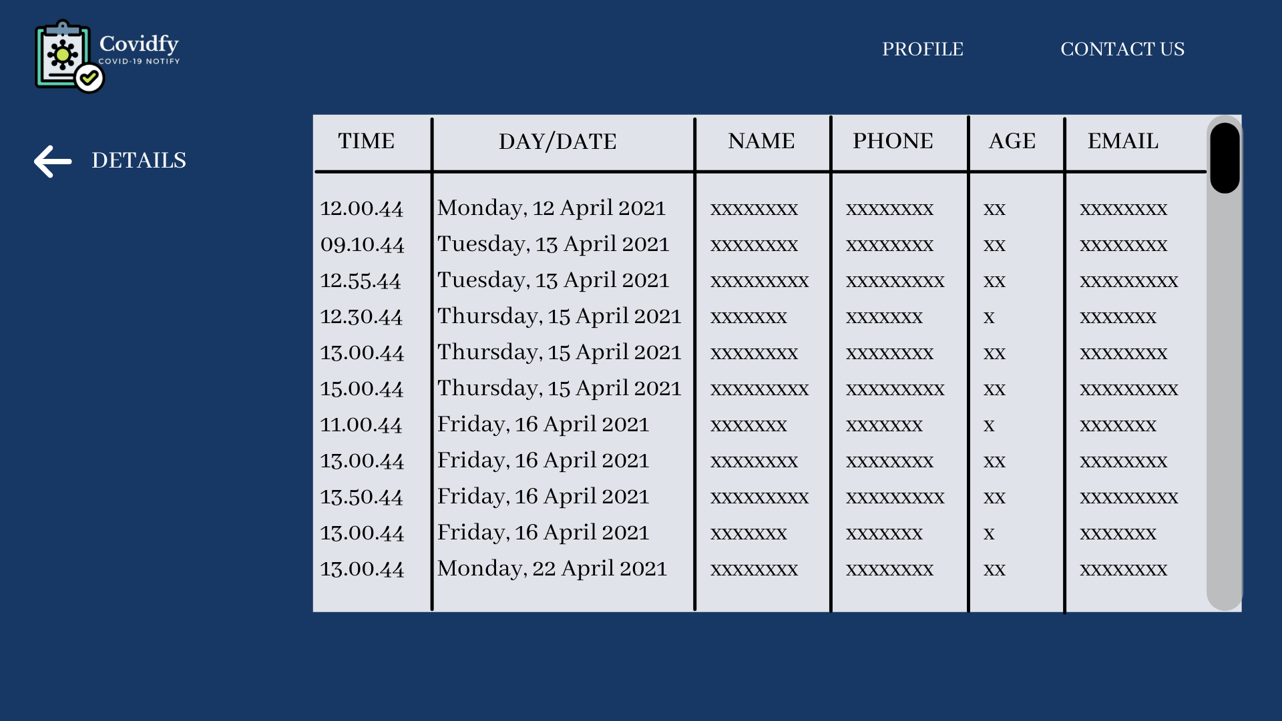

(c) Main page on phone Layout

(b) “CLICK FOR DETAILS”

When the business owner/manager logged in into their account, they will be redirected to the main page of the Covidfy webpage. In the main page of the business owner/manager, it will show the zoomed map of their venue/business location, the business/venue name and the number of people checked in to their venue. Below the number of people checked in to the venue, there is a link called ‘Click for details’. If the business manager click the link, it will be directed to the page that contains the details of the users checked in to the venue, which contain the information of the timestamp (time and day/date), the user’s name, phone number, age and email. For the business owner/manager main page, there will be 2 menus which is located on the right top of the webpage, which are ‘Profile’ and ‘Contact Us’. The implementation in the mobile’s version is the same but the size is adjusted to the mobile size. The menus in the mobile device will be smaller to fit into the mobile device.

1. 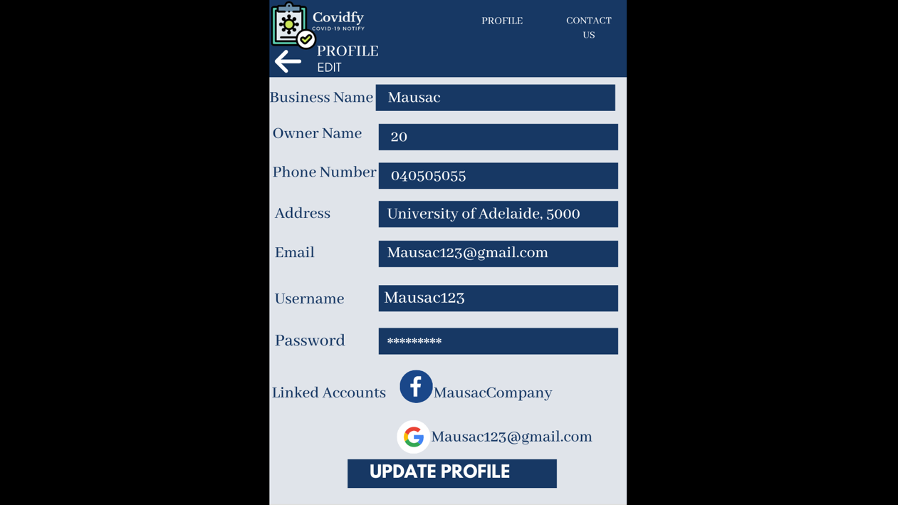Profile

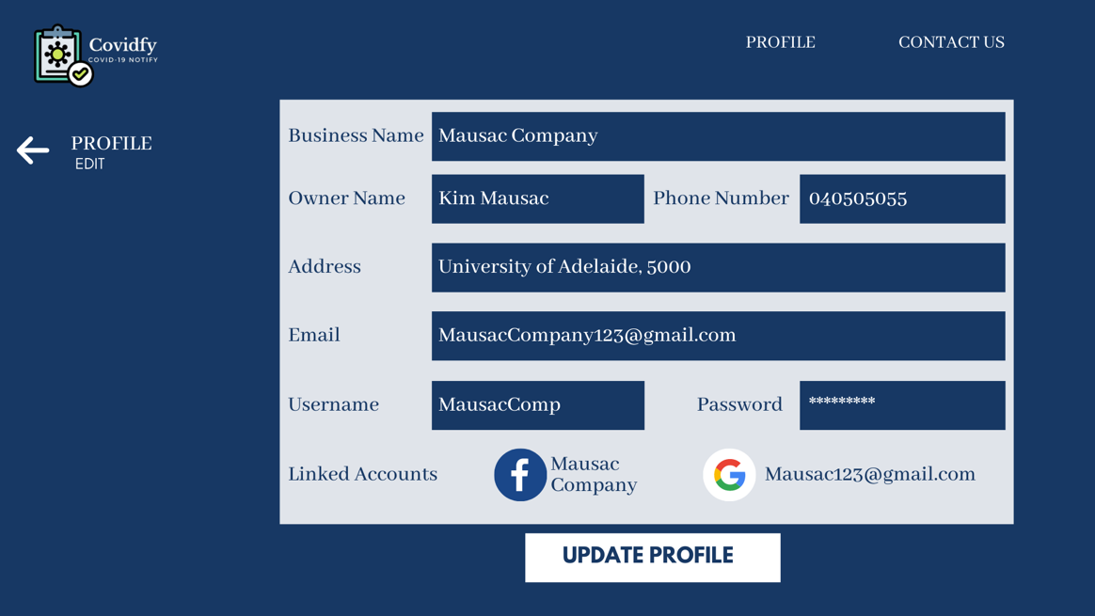

The ‘Profile’ menu will allow the business owner/manager to edit the information about their business/venue and link or unlink their Facebook and Google account. If the business owner/manager make some changes to their profile, they need to click the ‘Update Profile’ button in order to save the changes. In the webpage, there is a back button on the left side of the page. For the mobile device layout, it will be the same layout, but it is fixed into a device’s size and the back button will be moved to the top of the edit profile box. The other menus will still be the same.

1. Health Officials/Admins
2. 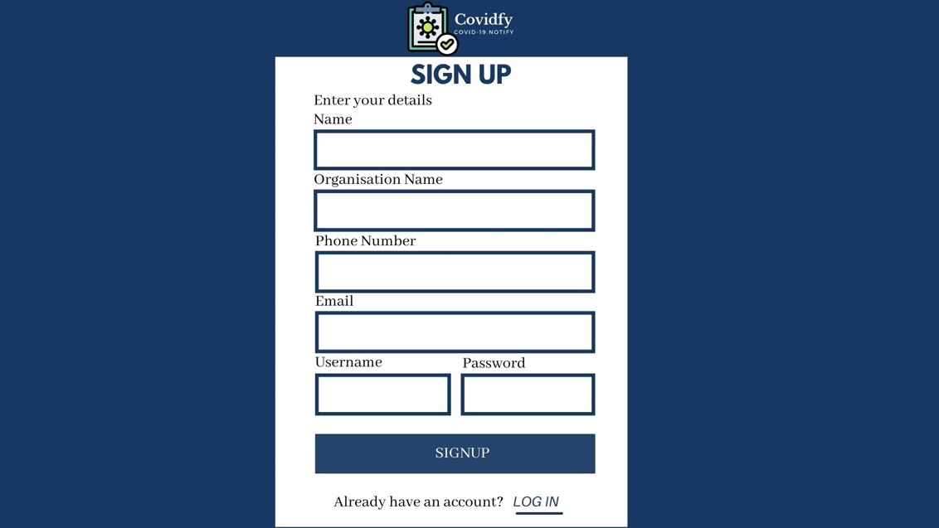Signup Page

If the health official/admin choose the sign up then they will be redirected to the ‘Signup’ page for health official/admin. In this page, the new users are required to provide their personal information, such as name, organization name, phone number, address, email and they also required to create a username and password. The username and password will be used as the venue/business’ identifier and being used to login to the Covidfy website. We also add the ‘Login’ link on the bottom of the page, just in case the user already have an existing account and it will be redirected to the ‘Login’ page.

1. 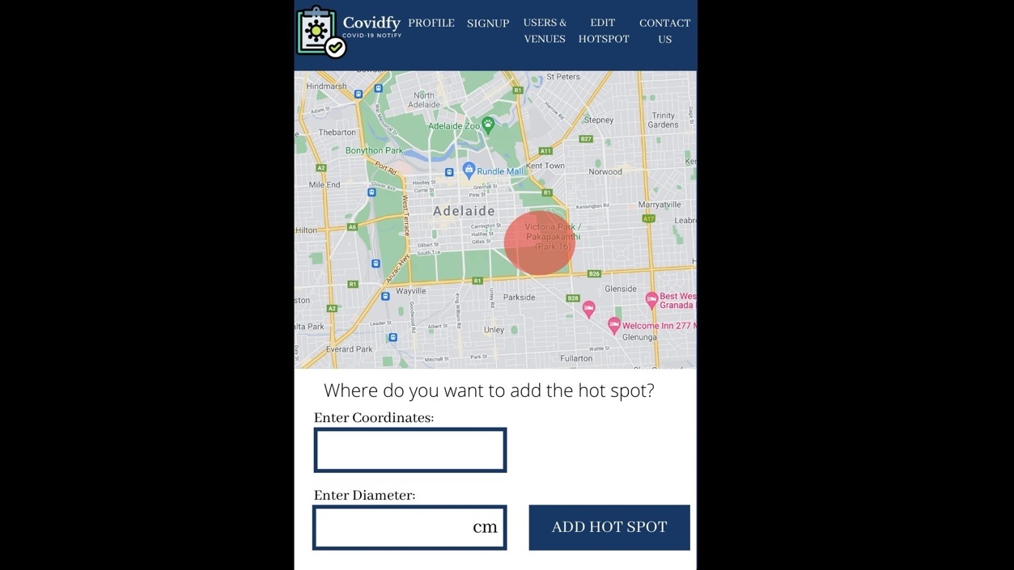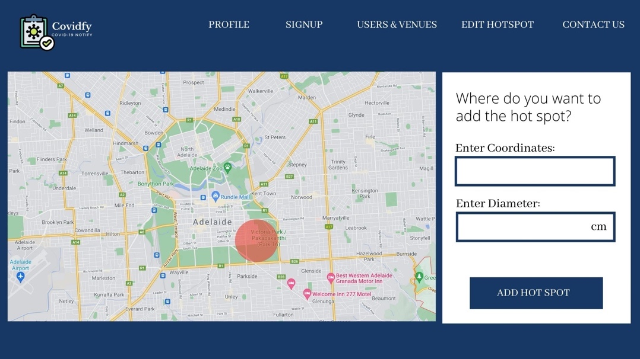Main Page

When the health official/admin logged in into their account, they will be redirected to the main page of the Covidfy webpage. In the main page of the health official/admin, it will show the overall map and enable the health official/admin to add a new hot spot to the map. In order to add a new hot spot, the health official/admin is required to fill in the coordinates of the new hotspot and the diameter of the circle. By clicking the ‘Add Hotspot’ button it will create a new hotspot based on the input and update the current map. The implementation of the health official/admin’s main page in the mobile device will be similar but the position of the ‘Add Hotspot’ is being moved to below the map. For the health official/admin’s main page, there will be 5 menus which are located on the right top of the webpage. The menus are ‘Profile’, ‘Signup’, ‘Users & Venues’, ‘Edit Hotspot’ and ‘Contact Us’. The implementation of menus in the mobile’s version is the same but the size is adjusted to the mobile size.

1. 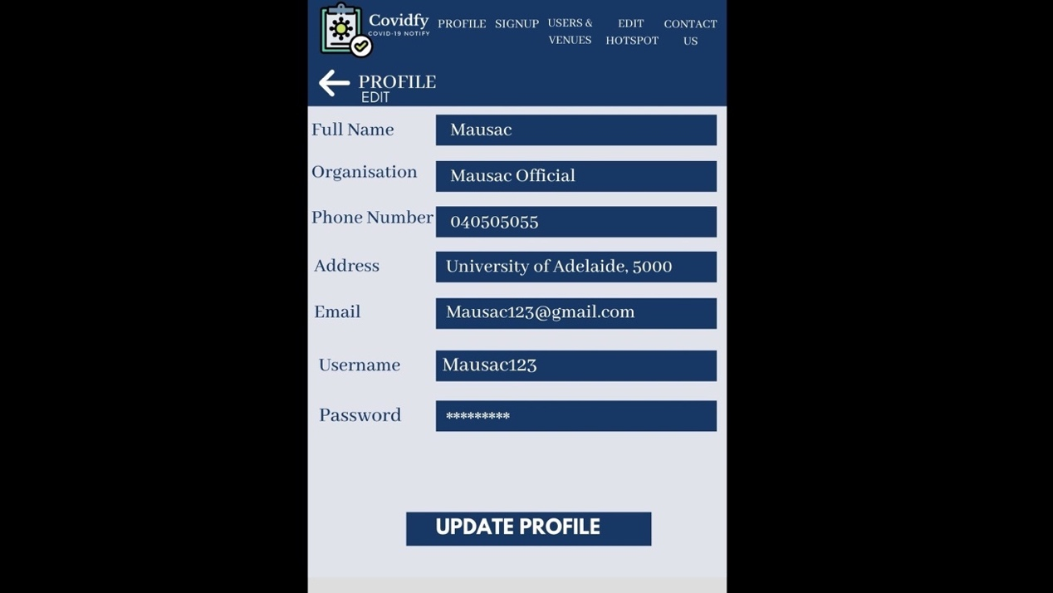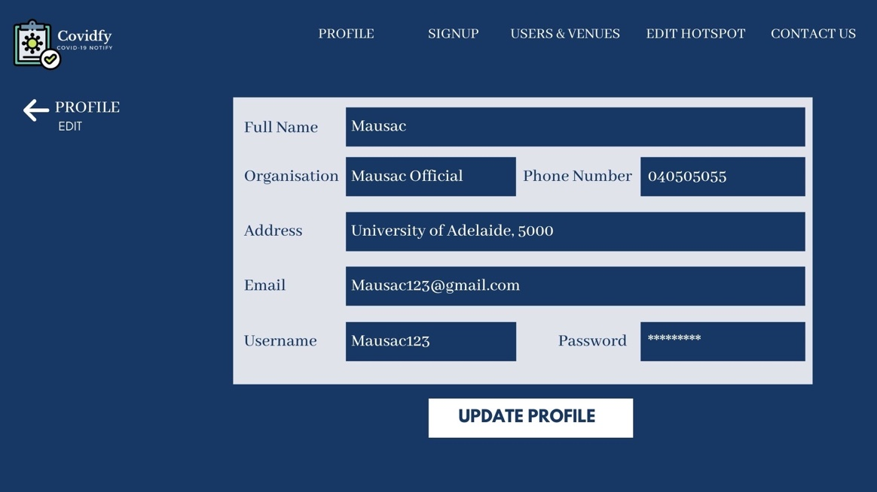Profile

The ‘Profile’ menu will allow the business owner/manager to edit their personal information. If the health official/admin make some changes to their profile, they need to click the ‘Update Profile’ button in order to save the changes. In the webpage, there is a back button on the left side of the page. For the mobile device layout, it will be the same layout, but it is fixed into a device’s size and the back button will be moved to the top of the edit profile box. The other menus will stay be the same.

1. Users & Venues

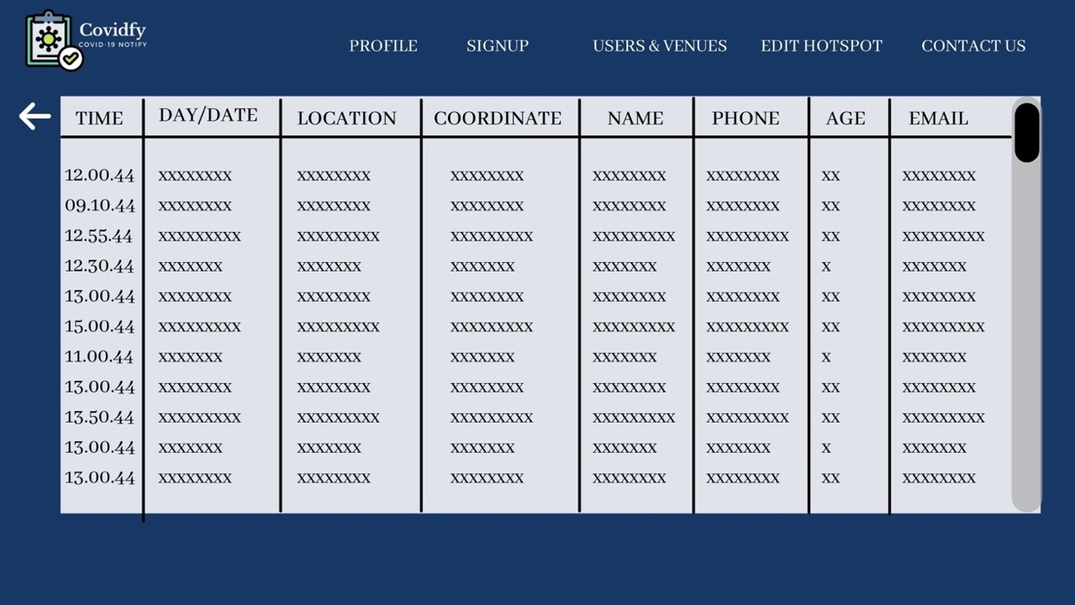

The ‘Users & Venues’ menu is for the health official/admin access the information both of the venue and users. The information contained will be the timestamp (time and day/date), location, coordinate, user’s name, phone, age and email.

1. 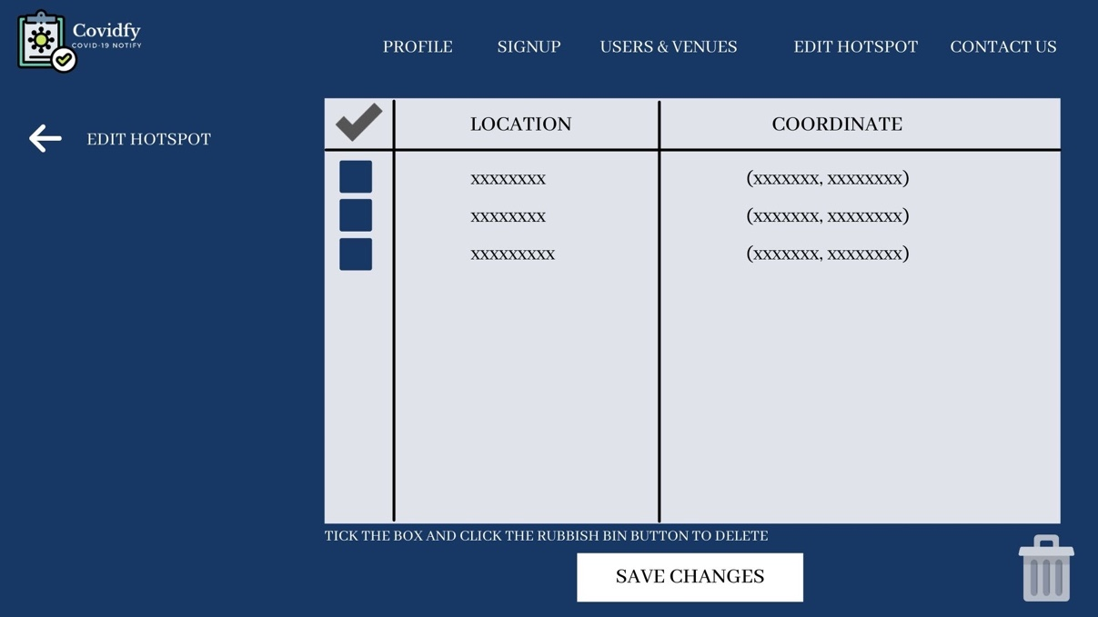Edit Hotspot

The ‘Edit Hotspot’ menu is for the health official/admin manage the current active hotspot. The way it work is if the user want to delete the hotspot, then put a tick on the box, and click the rubbish bin button. If the health official/admin made any changes on the current hotspots, then they need to click the ‘Save Changes’ button to update everything.

1. 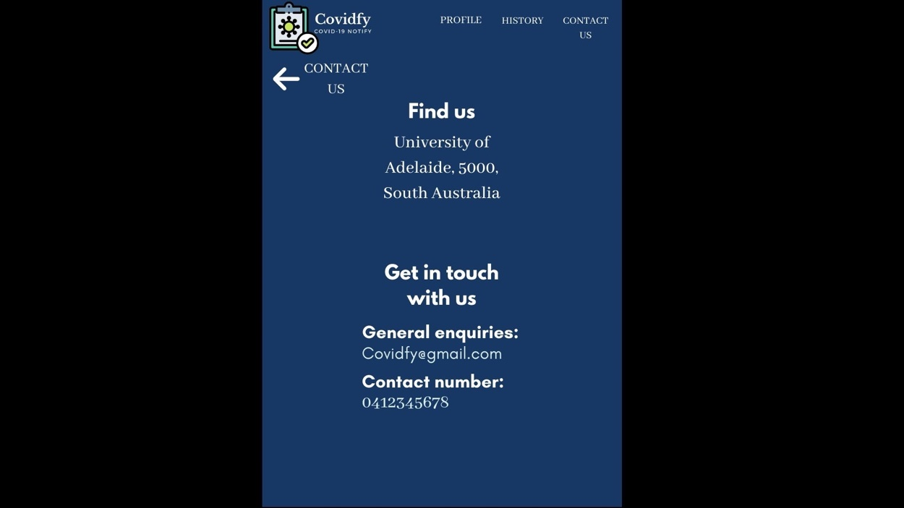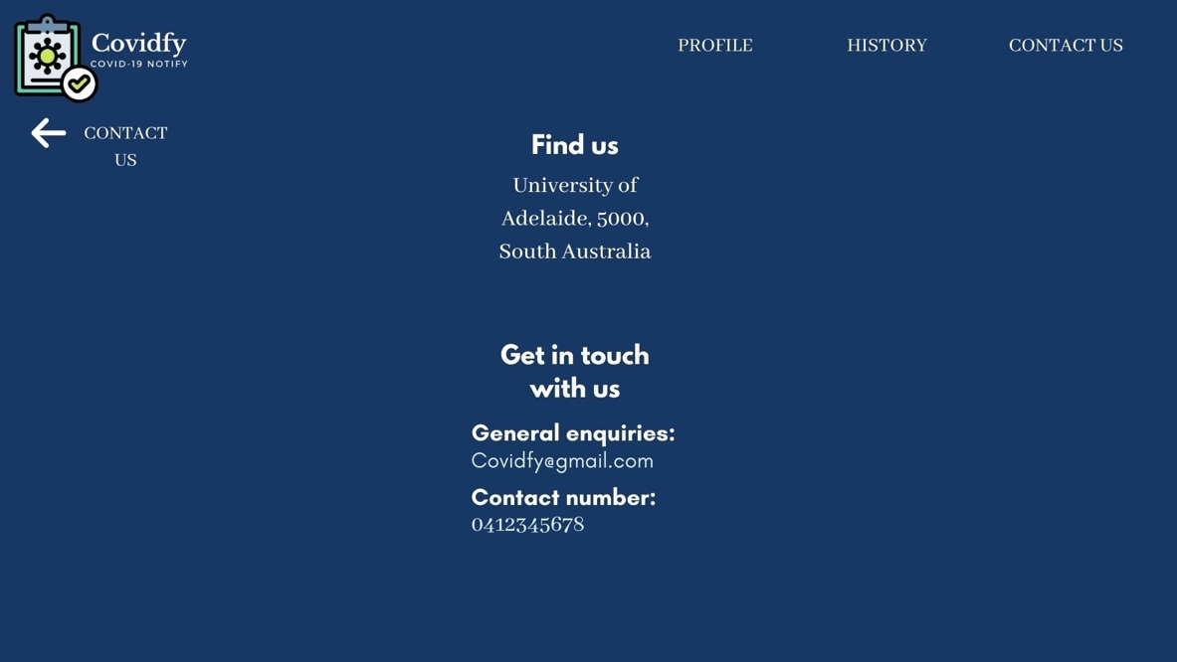Contact Us

The ‘Contact Us’ menus will contain information about our website, such as address and contact details (email and phone number). There will also a back button that will redirect the user back to the main page. The layout of the ‘Contact Us’ on the mobile phone device will be the same.

1. Components

The components of our website will be flexible based on the device that the users are using. For example, if the user are running the website on a laptop, then the interface will fit into the laptop screen. Likewise, if the user is running the website on a mobile phone, then the size of the website will be adjusted to fit the phone screen. Therefore, the components of our website will be stretch. Additionally, if the windows being resized, some components will change their position. For example, the back button when choosing a menu and the location details on the user’s main page. To be concise, our website will implement the HTML Responsive Web Design. The Responsive Web Design will enable the users to resize, shrink or enlarge the website. Thus, the website will look good on every device, such as desktops, tablets and mobile phones.

1. **Review**
2. Covid Updates – Current Hotspot

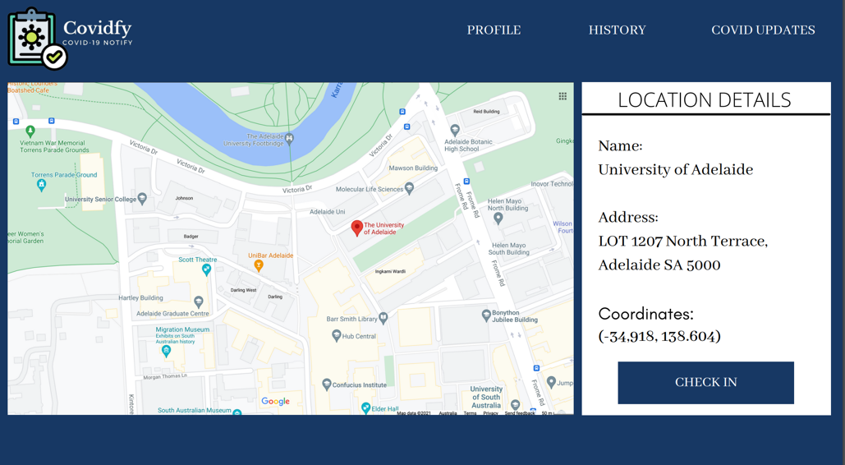

(a) User's old main page layout

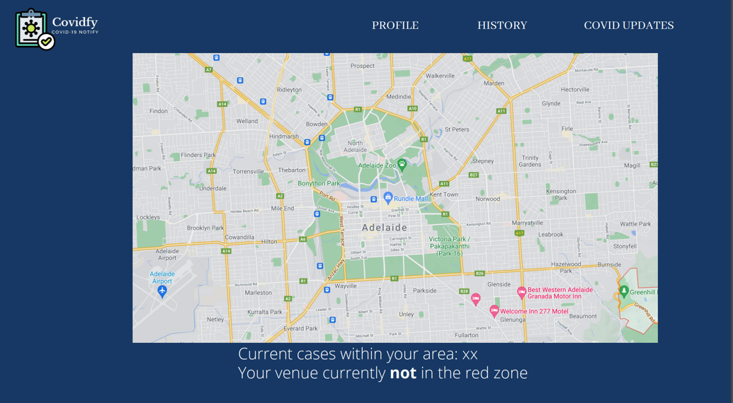

(b) The updated layout of the ‘Covid Updates’

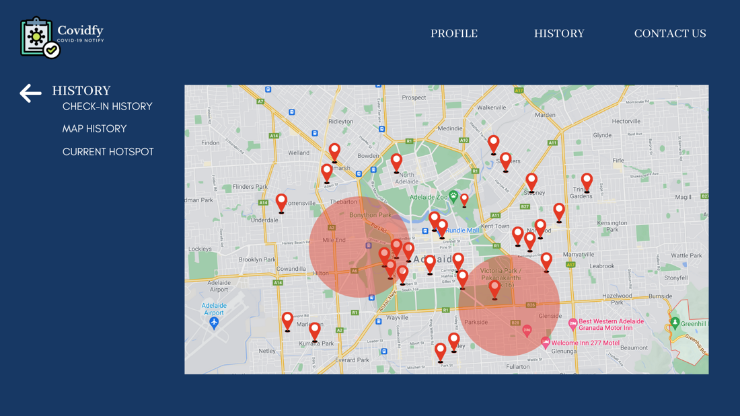

(c) The updated version of the ‘Covid Updates’ which has changed name to the ‘ Current Hotspot’ and be the part of the ‘History’

We realize that the users’ experience are the most important aspect on doing our website. Therefore, we are working our best to keep our users happy with the Covidfy website. The first thing we have revised is the user main page. Initially, we were planning to have the user main page contains the menu of ‘Profile’, ‘History’, ‘Covid Update’ and ‘Contact Us’. However, there’s a feedback from other peers said that the ‘Covid Updates’ menu could be combined with the ‘History’ menu. As the content of the ‘Covid Updates’ is quite similar to the content of the ‘History’ page. Initially, we planned to have the ‘History’ page to only contain the information of Check-in History and Map History. Where in the check-in history will contain data of the users last check-in information and the map history contain the maps with markers. Therefore, in order to minimize the users’ kinematic load, we decided to add the ‘Covid Updates’ as the part of History and changed the name into ‘Current Hotspot’. In the ‘Current Hotspot’ menu, it will show a map with circles that mark the current hotspot.

1. Contact Us

We also decided to add the Contact Us menu on top of our webpage. Therefore, if the users want to know more about us or contact us they could directly click the ‘Contact Us’ menu and it will directed to the link that contains contact information of our group.

1. 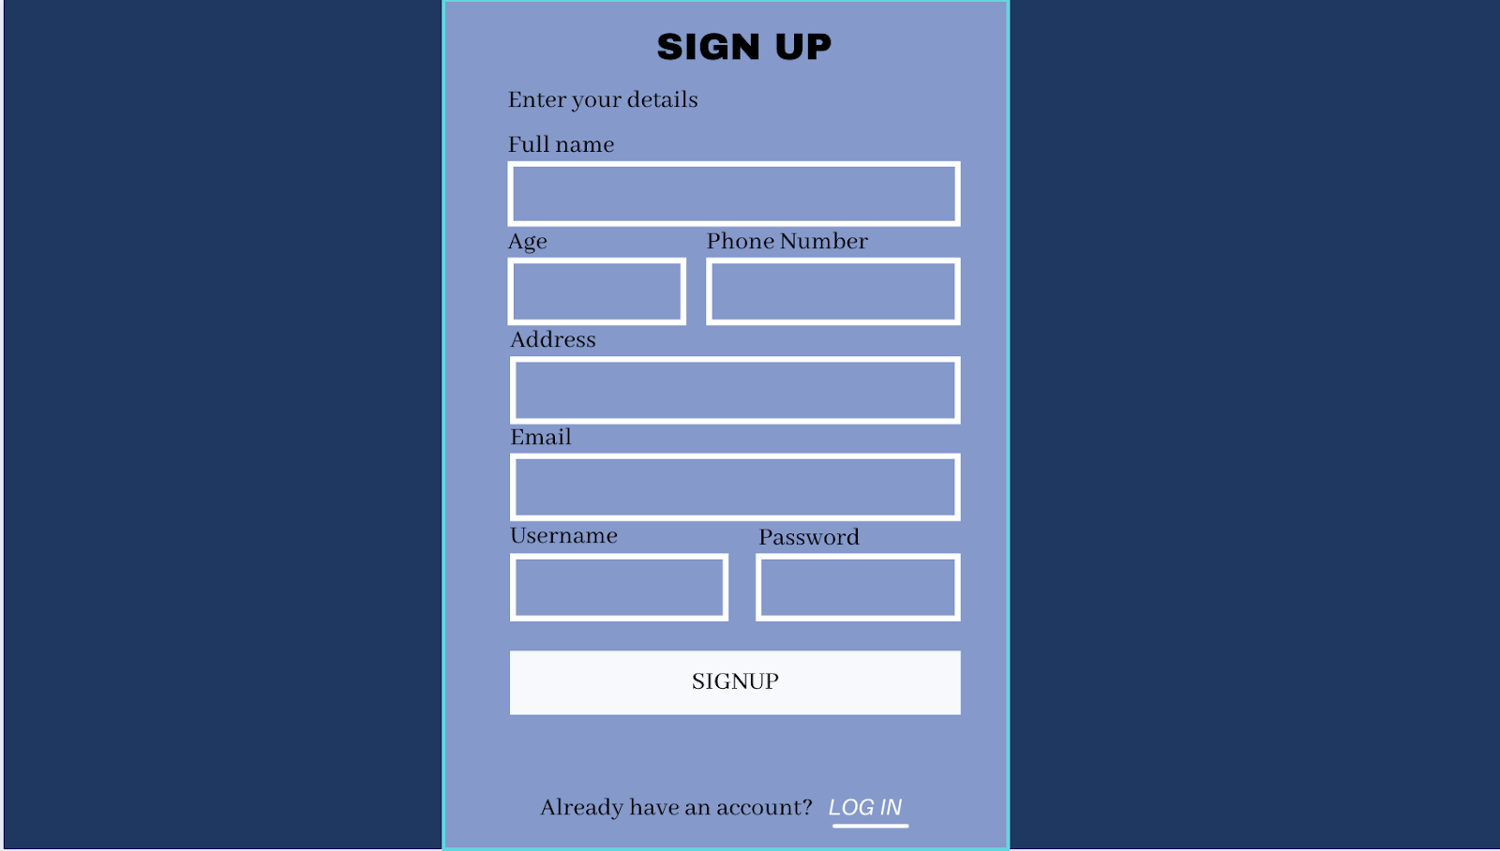Login and Signup Layout

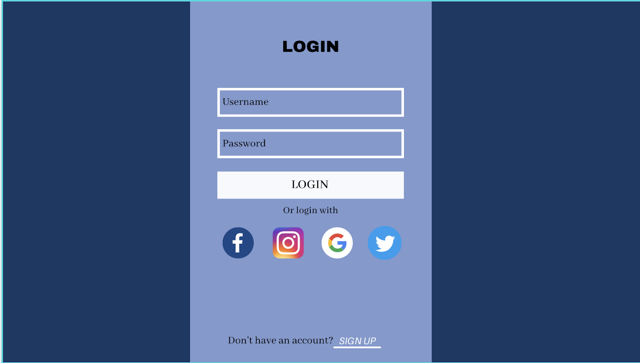

(a) The Older Design for the Login and Signup Page

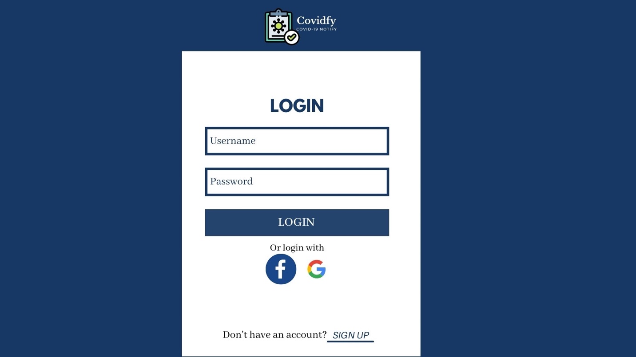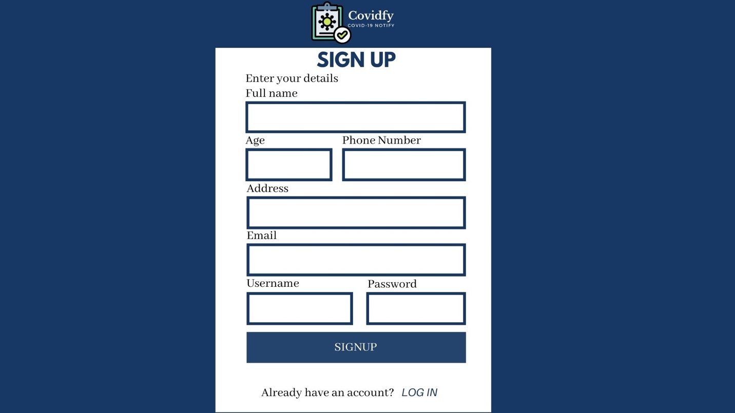

(b) The Updated Design for the Login and Signup Page

On our first design of the signup and login page, we designed the signup and login page box with the combination of dark blue, light blue, white and black colours. However, after a few consideration we feel like the colour combination is not appealing enough. Therefore, we changed the colour combination to dark blue and white, which is more refreshing to look at. Moreover, we also updated the linked social media account to only available to Facebook and Google account because we thought that the social media of Facebook and Google Account collects more data of the user than the Instagram and Twitter did.

1. 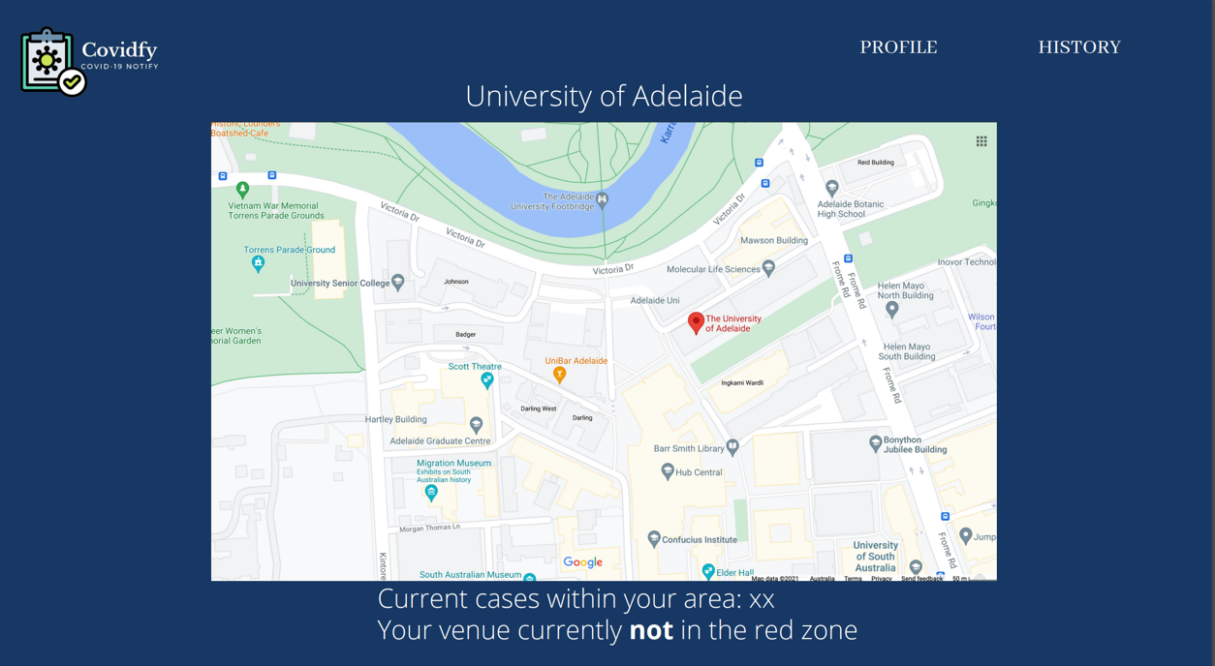Business Manager/Venue Main Page Layout

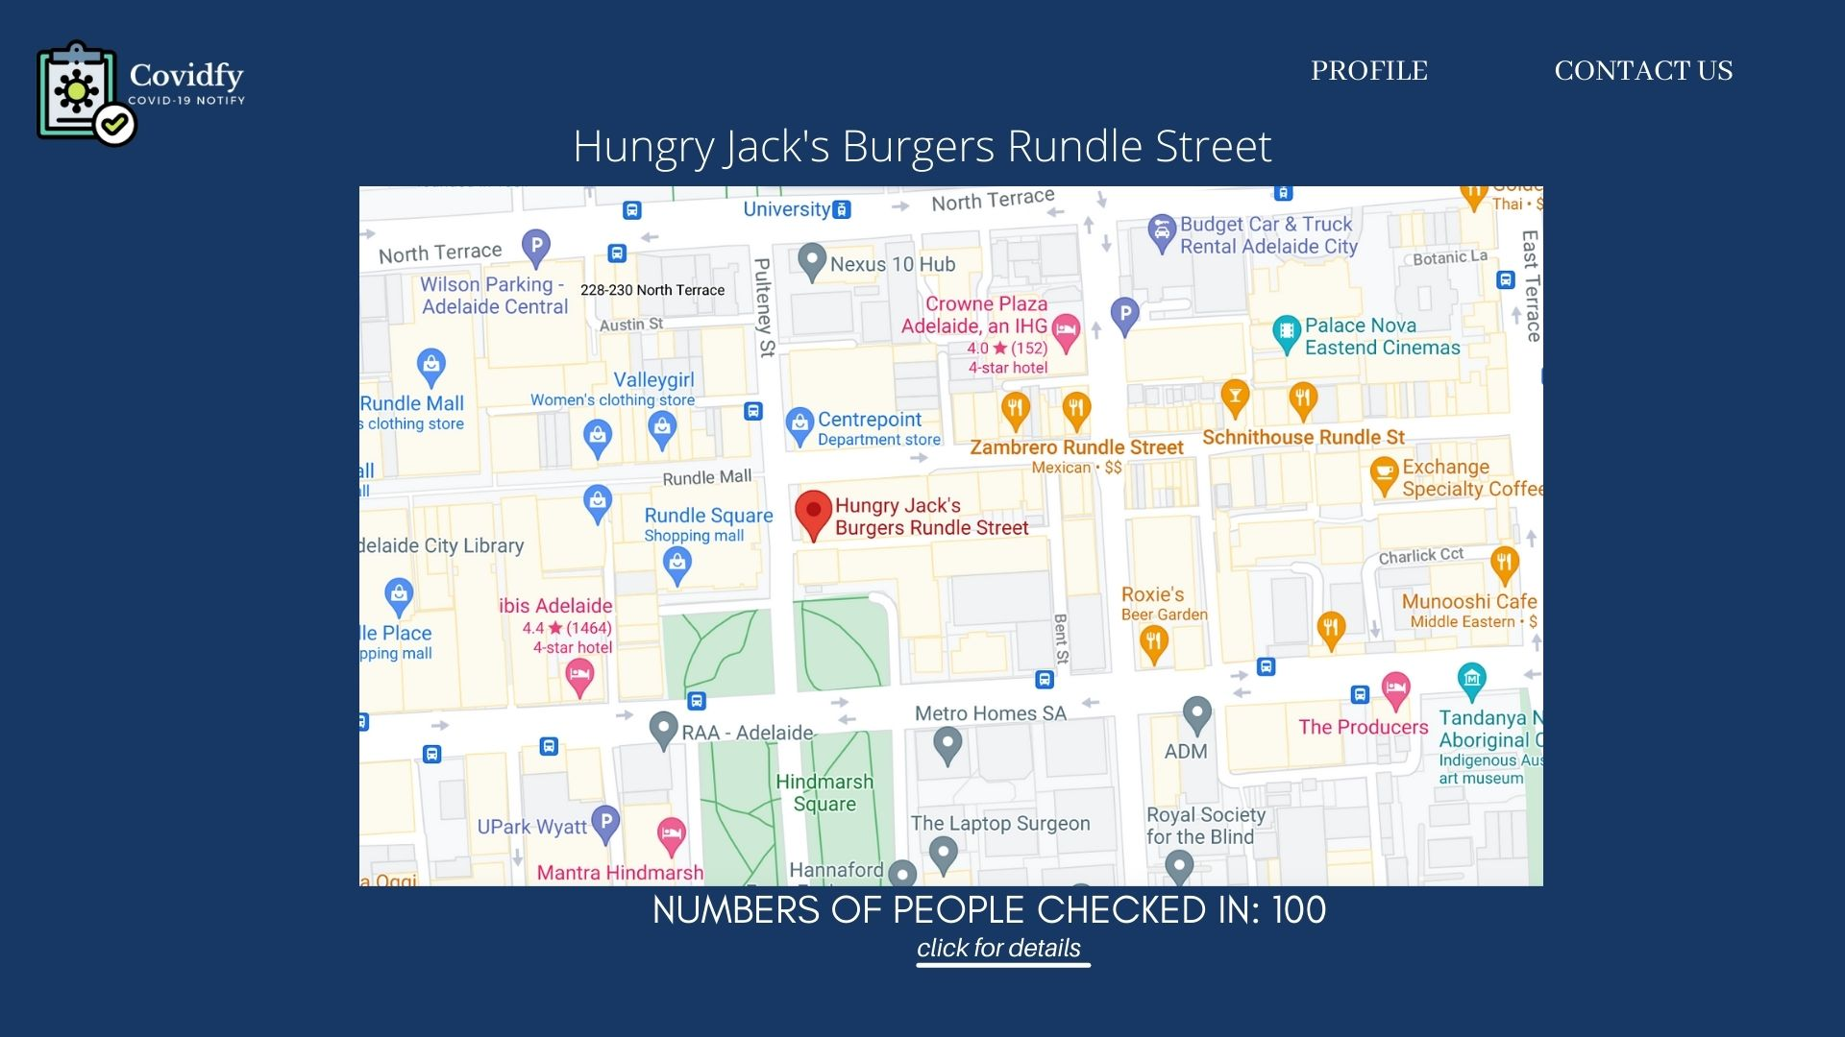

(b) The Updated Business Manager/Owner Main Page

(a) The Old Business Owner/Manager Main Page

Other than that, we also updated our business manager/admin main page to be more user friendly. In the first design, the venue main page only contain the basic information of the venue, such as the name of the location, the map, the number of cases in the area and whether the venue is on the red zone or not. However, after having a further discussion with other group members, we decided to change the content of the venue main page. As the result, the updated main page is now containing the zoomed map location of the venue, name of the location, and number of people checked in to the venue. We also get rid of the ‘History’ menu from the business manager/admin main page and as the return, we put the further information of the history to the link of ‘Click for Details’ which is located on the main page (below the number of users checked in). Therefore, this will reduce the kinematic load of the user as they does not need to move their cursor to the top of the page and can immediately access the ‘History’ page just by clicking the ‘Click for Details’ link. We also removed the ‘Current cases’ and ‘Whether the venue is on red zone or not’ as we think it is not too relevant for the business owner/managers main page.

1. **Data Plan**

Our website allow three roles of users to access our websites. Each type of roles have different features and purposes. The three roles, include the user, business owner/manager and the health official/admin.

1. User
2. Login

|  |  |
| --- | --- |
| Client | Username and password or linked social media account |
| Server | Full name, age, phone number, address, email, username, password, user type |

In the login feature, the user need to provide their username and password. While the server side will need to store the full name, age, phone number, address, email, username, password, user type. Then the server will look up on the database and find the matching username and password, if it is exist, the server will allow the client to access the page.

* Login Timeline

1. User input the username and password
2. Send request to the server
3. Server allow the access (if the username and password is exist)
4. Server send back the main page of the user (including their personal information (for edit profile feature))
5. Signup

|  |  |
| --- | --- |
| Client | Full name, age, phone number, address, email, username, password, user type |
| Server | Full name, age, phone number, address, email, username, password, user type |

In the signup page, the user is required to fill in their personal information and create a new username and password.

* Signup Timeline

1. Client click the signup link
2. Client choose the role
3. Client fill in the required information
4. Client click the ‘Signup’ button and data been send to the server
5. Server send the information back and allow the user to login to the website
6. GPS and Maps

The GPS and maps features in our websites is to check in and collect the information of the current position of the user, which will include the latitude and longitude value of the user’s coordinate. Moreover, the GPS and maps features will also be used to show the information of the check-in history of the users which is shown on a map.

|  |  |
| --- | --- |
| Client | GPS location |
| Server | Venue location, User ID, visit time |

* Check-in Timeline

1. The client will log in to website and send request to access of the main page
2. The server get the GET request and send back the information of the current position (coordinates) of the client
3. The map of the current position of user shown on the map
4. Client clicked check in button
5. The current position sent to the server
6. The server save the information of the client’s check in

* Current Hotspot Timeline

1. The user clicked the Current Hotspot button and send request to the server to access it
2. The server send the information of the current hot spots and markers that mark the location they have been visited before
3. Client will be able to see the current hotspot and their history check in on the map. Therefore, they could identify whether they been into the red zone or not.

* History Check-in

1. Client send request to access their history check-in on map
2. Server send back the information consist of maps and circles marking the red zone
3. Client will be able to see the red zone on the map
4. Edit profile

On the edit profile feature, the user will be able to edit their personal information and replace the information in the database.

* Edit profile timeline

1. Client send request to access the edit profile menu
2. Server send back the page of the edit profile
3. Client change information on the page by editing the text on the box
4. Client click the ‘Save changes’ button
5. The information being send to server
6. The server update the information of the client in the database
7. Client’s information successfully changed in the database
8. Contact us

The contact us will allow the user to see information about our website information such as address and personal contact.

* Contact us timeline

1. Client send request to access the contact us menu
2. Server send back the page of the contact us
3. Client will be able to see the contact us page in their device
4. Business Owner/Manager
5. Login

|  |  |
| --- | --- |
| Client | Username and password or linked social media account |
| Server | Business name, owner name, phone number, address, email, username, password, user type |

In the login feature, the manager need to provide their username and password, or simply using their linked social media account. While the server side will need to store the business name, owner name, phone number, address, email, username, password, user type. Then the server will look up on the database and find the matching username and password, if it is existing, the server will allow the client to access the page.

* Login Timeline

1. Client input the username and password
2. Send request to the server
3. Server allow the access (if the username and password is existed)
4. Server send back the main page of the client (including their personal information (for edit profile feature))
5. Signup

|  |  |
| --- | --- |
| Client | Business name, Owner name, phone number, address, email, username, password, user type |
| Server | Business name, Owner name, phone number, address, email, username, password, user type |

In the signup page, the manager is required to fill in their personal information and create a new username and password.

* Signup Timeline

1. Client click the signup link
2. Client choose their role
3. Client fill in the required information
4. Client click the ‘Signup’ button and data been send to the server
5. Server send the information back and allow the client to login to the website
6. GPS and Maps

The GPS and Maps will be shown on the main page of the venue manager/owner. It will show the location of the venue.

|  |  |
| --- | --- |
| Client | Shop ID |
| Server | Venue location, User ID, visit time |

* Main page timeline

1. Client send login request to the website
2. Server send the webpage content containing the map of the venue, the name and the number checked in to the venue.

* Check-in History

1. The client is logged in and got into the main page
2. The client clicked the ‘click for details’ to show the information of history of users checked in to the venue and send request to the server
3. The server send back the information of the history page
4. The client will be able to see the information of users that checked in to the venue
5. Profile

The profile feature will enable the business owner/manager to edit their business information in the database.

* Edit profile timeline

1. Client send request to access the edit profile menu
2. Server send back the page of the edit profile
3. Client change information on the page by editing the text on the box
4. Client click the ‘Save changes’ button
5. The information being send to server
6. The server update the information of the user in the database
7. Client’s information successfully changed in the database
8. Contact us

The contact us will allow the user to see information about our website information such as address and personal contact.

* Contact us timeline

1. Client send request to access the contact us menu
2. Server send back the page of the contact us
3. Client will be able to see the contact us page in their device
4. Health Officials/Admins
   * 1. Login /Sign up

New admin could only be signed up by the existing health official/admin by going to the ‘Signup’ menu on the main page. Then, they will be redirected to the health official/admin signup page, for them to fill out their personal information. The login page of the health admin will be the same as the other users’ role.

|  |  |
| --- | --- |
| Client | Username and password |
| Server | Full name, age, phone number, address, email, username, password, user type |

* Login Timeline

1. User input the username and password
2. Send request to the server
3. Server allow the access (if the username and password is exist)
4. Server send back the main page of the user (including their personal information (for edit profile feature))
   * 1. Database

For the health official/admin, they will have access to modify the database and check who have been to the single location. And the admin can know the exact locations of the user have been to.

* Database Timeline

1. Admin click into the database page
2. Drag all the data from the server
3. Server return the whole database to the admin
   * 1. Red zone

Admin can set up a new hotspot by adding the coordinates and the diameter of the circle want to be add. Other than that, the health official could also edit the current hotspot in the area.

* Red zone timeline

1. Admin request the whole database from the server
2. Server return the whole database to admin
3. Admin choose which point is center and send the information to the server
4. Server receive the information and indicate the chosen point to be the center and made a circle base on that point to become a red zone
5. The database updated
   * 1. Manage Users & Venues

The admin can access and manage the personal information of users and venues. Other than that, the admin could also check a single user history and get information about the locations the user checked in before. Therefore, if the user got covid, the health officials could get information about the location the user visited before and the other users that get contact with.

* Manage timeline

1. Admin send request to review the whole database
2. Server return the database
3. Admin the choose the specific venue or user by filter in SQL and the full information of them.
4. Then admin can see which point got the most people stay together and set that point to be the red zone.
5. Further Explanation

In our opinion, the data should all be stored on the server to prevent the information to be stolen as it will be easier for people to crack in and steal the data if the data is placed on local. In order to retrieve data from the server, the client will need to send request to the server to get access of the data. Other than that, the client send the data to the server by ‘triggering the action’, for example by clicking the ‘Signup’ or ‘Update changes’ buttons. Each role will have their own username and password. The username for every user will have their unique User ID and it will be the identifier of each users. This is to prevent the tragedy of users having the same name.

1. 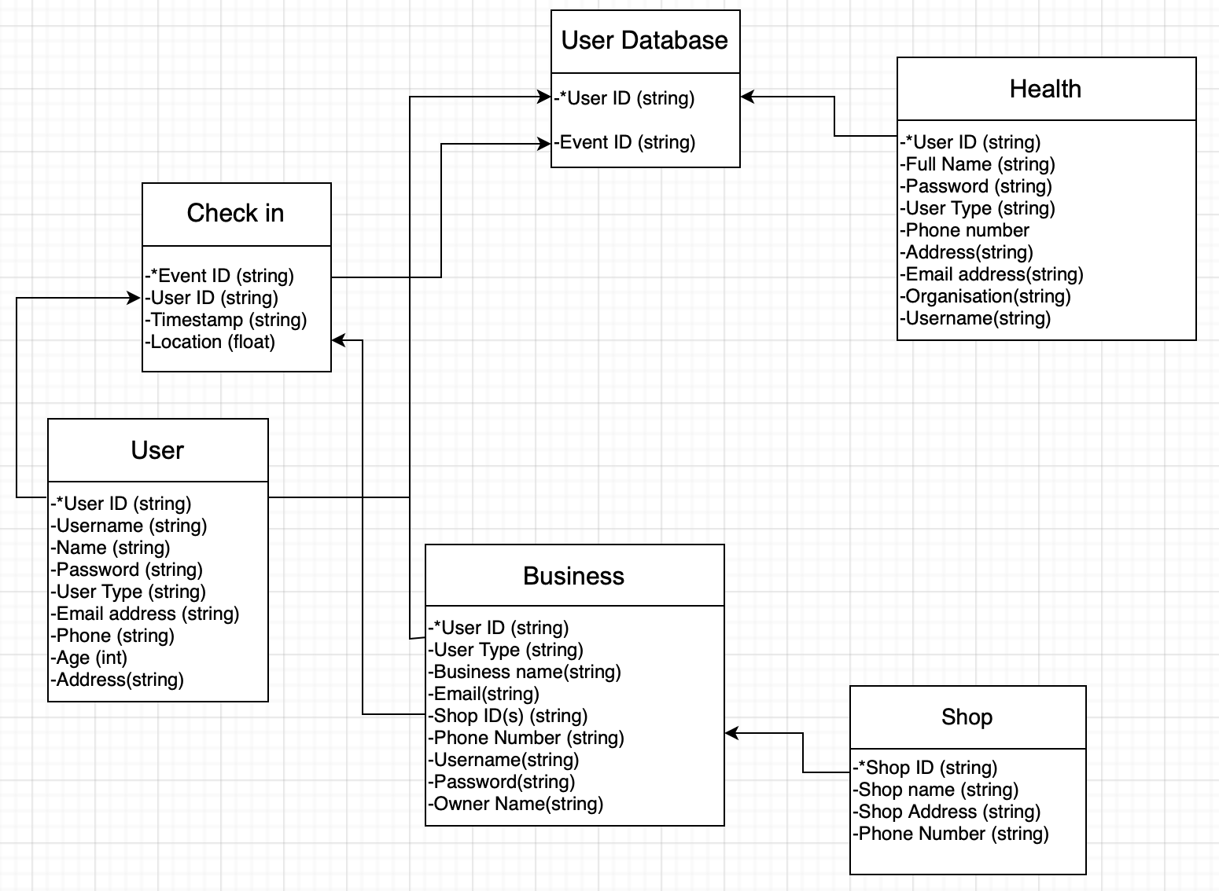**Database Schema**

The database schema of the Covidfy website application will be collecting the User ID, which is the unique identifier that we assigned to each username, and the Event ID. The Event ID is created when a user check in to a location by using the GPS inside our apps. The Event ID will contain the information of User ID, Timestamp (time and day/date) and location. For the user, the key will be the User ID and the user has other information such as name, username, password, email address, address, phone number, age and user type.

The user type is to determine what kind of data that the user could access in their webpage. Different user type can access different data. For example, the user type of ‘User’ could do the check-in, edit profile and view their check-in history. While for the user type of ‘Business Owner/Manager’, they will be able to edit their business’ information, the number of people checked-in to their shop and access the checked-in users’ information. On the other hand, the user type of ‘Health Official/Admin’ will have the access on making change the database, add and edit the current hotspots in an area. Additionally, the shop column is created for the business people that have more than one shop. This column will make them easier to manage their shops in one single account instead of creating a new account for every shops.

1. 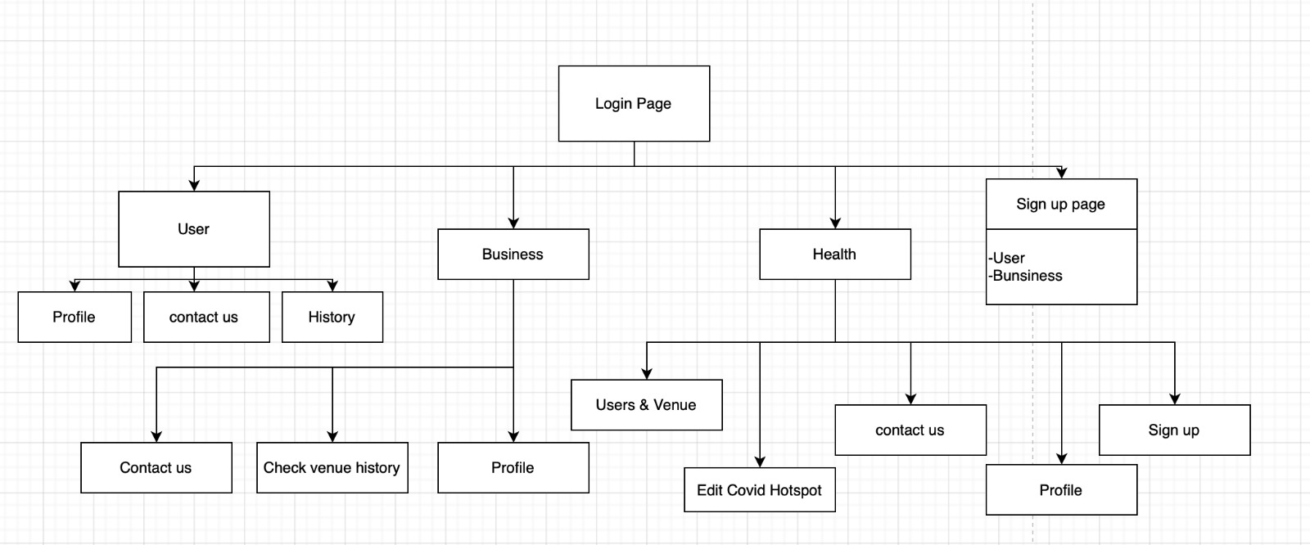**Website Layout Schema**

This is the breakdown of our website’s functions. As for every user type will have different type of layout and functions that they could do in their webpage.